|  |  |  |  |  |  |  |  |  |  |  |  |
| --- | --- | --- | --- | --- | --- | --- | --- | --- | --- | --- | --- |
| Present State | | | Next state | | | Flip-flop inputs | | | | | |
| Q2 | Q1 | Q0 | Q2 | Q1 | Q0 | J2 | K2 | J1 | K1 | J0 | K0 |
| 0 | 0 | 0 | 0 | 0 | 1 | 0 | ✖ | 0 | ✖ | 1 | ✖ |
| 0 | 0 | 1 | 0 | 1 | 0 | 0 | ✖ | 1 | ✖ | ✖ | 1 |
| 0 | 1 | 0 | 0 | 1 | 1 | 0 | ✖ | ✖ | 0 | 1 | ✖ |
| 0 | 1 | 1 | 1 | 0 | 0 | 1 | ✖ | ✖ | 1 | ✖ | 1 |
| 1 | 0 | 0 | 1 | 0 | 1 | ✖ | 0 | 0 | ✖ | 1 | ✖ |
| 1 | 0 | 1 | 1 | 1 | 0 | ✖ | 0 | 1 | ✖ | ✖ | 1 |
| 1 | 1 | 0 | 1 | 1 | 1 | ✖ | 0 | ✖ | 0 | 1 | ✖ |
| 1 | 1 | 1 | 0 | 0 | 0 | ✖ | 1 | ✖ | 1 | ✖ | 1 |

For J2 , the K-map would be,

|  |  |  |  |  |
| --- | --- | --- | --- | --- |
|  | Q1**'** Q0**'** | Q1**'** Q0 | Q1Q0 | Q1 Q0**'** |
| Q2**'** | 0 | 0 | 1 | 0 |
| Q2 | ✖ | ✖ | ✖ | ✖ |

J2 = Q1Q0

For K2 , the K-map would be,

|  |  |  |  |  |
| --- | --- | --- | --- | --- |
|  | Q1**'** Q0**'** | Q1**'** Q0 | Q1Q0 | Q1 Q0**'** |
| Q2**'** | ✖ | ✖ | ✖ | ✖ |
| Q2 | 0 | 0 | 1 | 0 |

K2 = Q1Q0

For J1 , the K-map would be,

|  |  |  |  |  |
| --- | --- | --- | --- | --- |
|  | Q1**'** Q0**'** | Q1**'** Q0 | Q1Q0 | Q1 Q0**'** |
| Q2**'** | 0 | 1 | ✖ | ✖ |
| Q2 | 0 | 1 | ✖ | ✖ |

J1 = Q0

For K1 , the K-map would be,

|  |  |  |  |  |
| --- | --- | --- | --- | --- |
|  | Q1**'** Q0**'** | Q1**'** Q0 | Q1Q0 | Q1 Q0**'** |
| Q2**'** | ✖ | ✖ | 1 | 0 |
| Q2 | ✖ | ✖ | 1 | 0 |

K1 = Q0

For J0 , the K-map would be,

|  |  |  |  |  |
| --- | --- | --- | --- | --- |
|  | Q1**'** Q0**'** | Q1**'** Q0 | Q1Q0 | Q1 Q0**'** |
| Q2**'** | 1 | ✖ | ✖ | 1 |
| Q2 | 1 | ✖ | ✖ | 1 |

J0 = 1

For K0 , the K-map would be,

|  |  |  |  |  |
| --- | --- | --- | --- | --- |
|  | Q1**'** Q0**'** | Q1**'** Q0 | Q1Q0 | Q1 Q0**'** |
| Q2**'** | ✖ | 1 | 1 | ✖ |
| Q2 | ✖ | 1 | 1 | ✖ |

K0 = 1

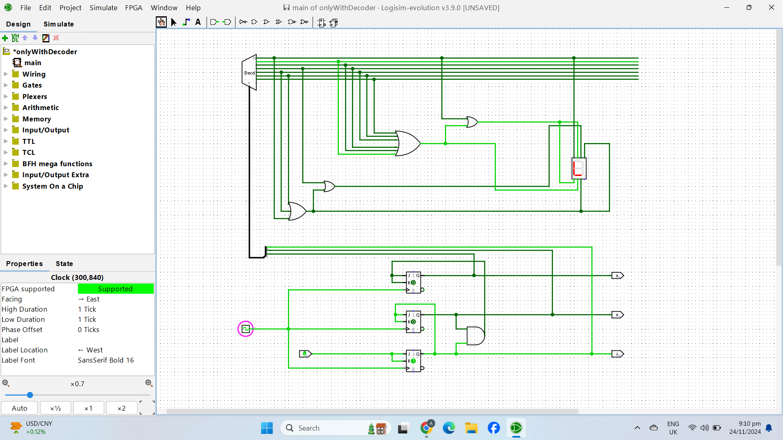

|  |  |  |  |  |  |  |  |  |  |  |
| --- | --- | --- | --- | --- | --- | --- | --- | --- | --- | --- |
| Present State | | | Next State | | | | Flip-flop inputs | | | |
| Q2 | Q1 | Q0 | | Q2 | Q1 | Q0 | | T2 | T1 | T0 |
| 0 | 0 | 0 | | 0 | 0 | 1 | | 0 | 0 | 1 |
| 0 | 0 | 1 | | 0 | 1 | 0 | | 0 | 1 | 1 |
| 0 | 1 | 0 | | 0 | 1 | 1 | | 0 | 0 | 1 |
| 0 | 1 | 1 | | 1 | 0 | 0 | | 1 | 1 | 1 |
| 1 | 0 | 0 | | 1 | 0 | 1 | | 0 | 0 | 1 |
| 1 | 0 | 1 | | 1 | 1 | 0 | | 0 | 1 | 1 |
| 1 | 1 | 0 | | 1 | 1 | 1 | | 0 | 0 | 1 |
| 1 | 1 | 1 | | 0 | 0 | 0 | | 1 | 1 | 1 |

For T2 , the K-map would be,

|  |  |  |  |  |
| --- | --- | --- | --- | --- |
|  | Q1**'** Q0**'** | Q1**'** Q0 | Q1Q0 | Q1 Q0**'** |
| Q2**'** | 0 | 0 | 1 | 0 |
| Q2 | 0 | 0 | 1 | 0 |

T2 = Q1Q0

For T1 , the K-map would be,

|  |  |  |  |  |
| --- | --- | --- | --- | --- |
|  | Q1**'** Q0**'** | Q1**'** Q0 | Q1Q0 | Q1 Q0**'** |
| Q2**'** | 0 | 1 | 1 | 0 |
| Q2 | 0 | 1 | 1 | 0 |

T1 = Q0

For T0 , the K-map would be,

|  |  |  |  |  |
| --- | --- | --- | --- | --- |
|  | Q1**'** Q0**'** | Q1**'** Q0 | Q1Q0 | Q1 Q0**'** |
| Q2**'** | 1 | 1 | 1 | 1 |
| Q2 | 1 | 1 | 1 | 1 |

T0 = 1

|  |  |  |  |  |  |  |  |  |  |  |
| --- | --- | --- | --- | --- | --- | --- | --- | --- | --- | --- |
| Present State | | | Next State | | | | Flip-flop inputs | | | |
| Q2 | Q1 | Q0 | | Q2 | Q1 | Q0 | | D2 | D1 | D0 |
| 0 | 0 | 0 | | 0 | 0 | 1 | | 0 | 0 | 1 |
| 0 | 0 | 1 | | 0 | 1 | 0 | | 0 | 1 | 0 |
| 0 | 1 | 0 | | 0 | 1 | 1 | | 0 | 1 | 1 |
| 0 | 1 | 1 | | 1 | 0 | 0 | | 1 | 0 | 0 |
| 1 | 0 | 0 | | 1 | 0 | 1 | | 1 | 0 | 1 |
| 1 | 0 | 1 | | 1 | 1 | 0 | | 1 | 1 | 0 |
| 1 | 1 | 0 | | 1 | 1 | 1 | | 1 | 1 | 1 |
| 1 | 1 | 1 | | 0 | 0 | 0 | | 0 | 0 | 0 |

For D2 , the K-map would be,

|  |  |  |  |  |
| --- | --- | --- | --- | --- |
|  | Q1**'** Q0**'** | Q1**'** Q0 | Q1Q0 | Q1 Q0**'** |
| Q2**'** | 0 | 0 | 1 | 0 |
| Q2 | 1 | 1 | 0 | 1 |

D2 =Q1**'** Q2  **+** Q0**'** Q2 **+** Q0 Q1

For D1 , the K-map would be,

|  |  |  |  |  |
| --- | --- | --- | --- | --- |
|  | Q1**'** Q0**'** | Q1**'** Q0 | Q1Q0 | Q1 Q0**'** |
| Q2**'** | 0 | 1 | 0 | 1 |
| Q2 | 0 | 1 | 0 | 1 |

D1 = Q1**'** Q0  **+** Q1 Q0**'**

For D0 , the K-map would be,

|  |  |  |  |  |
| --- | --- | --- | --- | --- |
|  | Q1**'** Q0**'** | Q1**'** Q0 | Q1Q0 | Q1 Q0**'** |
| Q2**'** | 1 | 0 | 0 | 1 |
| Q2 | 1 | 0 | 0 | 1 |

D0 = Q0**'**